# Display and Modes

The display features three sections: numeric, dot matrix and fixed symbols. The numeric section features a minus sign and 12 digits for the mantissa, as well as a minus sign and 3 digits for the exponent. The dot matrix is 6 dots high and 43 dots wide, allowing for some 7 to 12 characters, depending on their widths. The fixed symbols (except the big “=”) are called *annunciators*, and are for indicating modes.

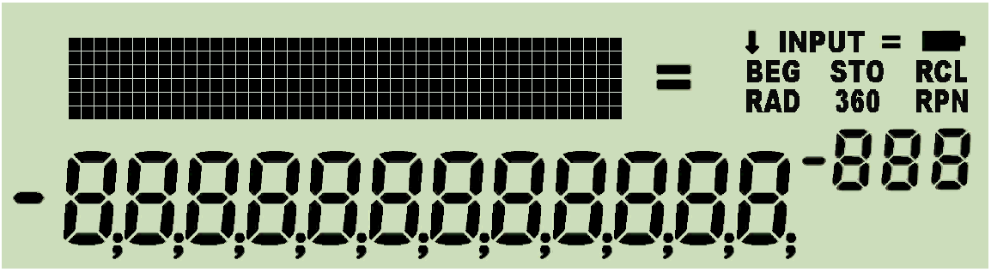

The dot matrix section above is used for

1. indicating some more modes than the annunciators allow,
2. passing additional information to the user.

The numeric section in the lower part of the LCD is used for displaying numbers in different formats, for status, or messages.

If two or more requests concur for display space, the items will be shown according to their priorities as follows:

1. error messages as described in a *paragraph further below*,
2. special information as explained below,
3. information about the modes the calculator is running in.

The *annunciators* or specific characters in the LCD signal the modes:

|  |  |  |  |  |  |  |  |  |  |  |  |  |  |  |  |  |
| --- | --- | --- | --- | --- | --- | --- | --- | --- | --- | --- | --- | --- | --- | --- | --- | --- |
| **Integer base or mode name** | 2 | 3 | 4 | 5 | 6 | 7 | 8 | 9 | 10 | 11 | 12 | 13 | 14 | 15 | 16 | DECM |
| **Signaled by … in the exponent** | **b** | **3** | **4** | **5** | **6** | **7** | **o** | **9** | **d** | **-1** | **-2** | **-3** | **-4** | **-5** | **h** |  |
| **Set by …** |  | BASE3, … , BASE7, , BASE9, , … , BASE15 | | | | | | | | | | | | |  |  |
| **Cleared by …** | any other BASE setting, FRACT, ,  **.** , , , , TIME, and  will set DECM | | | | | | | | | | | | | | | |

|  |  |  |  |  |  |  |
| --- | --- | --- | --- | --- | --- | --- |
| **Mode name** | PRG |  |  |  |  | FRC |
| **Signaled by …** | ***STO*** | ***INPUT*** | ***360*** | ***RAD*** | **G** |  |
| **Set by …** |  | ON |  |  |  | ,  2nd  in input BASE1, FRACT |
| **Cleared by …** |   |  OFF  |   |   |   | BASE ≠ 1 , TIME,   , ,  |

***BEG*** indicates the program pointer standing at step 000 of program memory. A running program is signaled by a flashing ***RCL*** annunciator. ***RPN*** may be lit permanently. Time modes (12h / 24h) are seen in the time string directly. The numeric format of fraction mode is unambiguous as well. Further settings are signaled in the dot matrix section, like the different date modes being indicated there by **Y.MD** or **M.DY**. Defaults D.MY and DECM are not indicated. Please check the examples below.

Some mode and display settings may be stored and recalled collectively by STOM and RCLM. These are stack depth and contrast set, complete decimal display settings, trig mode, choices for date and time display, the parameters of integer and fraction mode, curve fitting model and rounding mode selected. STOM stores this information in the register you specify. RCLM recalls the contents of such a register and sets the calculator modes accordingly. Please note the user is responsible for recalling valid mode data – else the WP 34S may be driven into a lockup state! See the *index of operations* for more information about changing modes and the individual commands employed.

Some regional combinations may be set at once using a single command:

* SETCHN sets 24h, Y.MD, decimal point, and E3OFF;
* SETEUR sets 24h, D.MY, decimal comma, E3ON, and JG1582 (these settings apply also to South America);
* SETIND sets 24h, D.MY, decimal point, E3OFF, and JG1752;
* SETUK sets 12h, D.MY, decimal point, E3ON, and JG1752.
* SETUSA sets 12h, M.DY, decimal point, E3ON, and JG1752;

Please note the people living in the area of the former Soviet Union, in South Africa, Indonesia, and Vietnam use the decimal comma as well, but have different settings for dates and times.

Especially the angular modes deserve a closer look: there are three of them, DEG, RAD, and GRAD. And degrees (DEG) may be displayed in decimal numbers as well as in hours, minutes, seconds and hundredth of seconds (H.MS). Conversions are provided for going from one to the other:

|  |  |  |  |  |  |
| --- | --- | --- | --- | --- | --- |
| From  to | degrees H.MS | decimal  degrees | radians | gon (grad) | current angular mode |
| degrees H.MS | — | 🡪H.MS | — | — | — |
| decimal degrees | 🡪H .d | — | rad🡪° | G🡪° | 🡪DEG |
| radians | — | °🡪rad | — | G🡪rad | 🡪RAD |
| gon/grad | — | °🡪G | rad🡪G | — | 🡪GRAD |
| current angular mode | — | DEG🡪 | RAD🡪 | GRAD🡪 | — |

Please see the *index of operations* for the commands printed on white background, and the *catalog of unit conversions* for those printed on yellow.

Some commands and modes use the display in a special way. They are listed below in order of falling priority:

1. **VERS** generates a display similar to the one shown on the title page of this manual. Pressing any key will delete this message and return to previous state.
2. **SHOW** displays the full mantissa of ***x***, i.e. all sixteen digits present internally. E.g.  returns

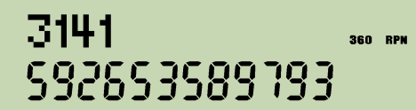.

Pressing any key will return to previous display.

1. **STATUS** shows the status of 30 user flags very concisely in one display, allowing an immediate status overview after some training. If e.g. flags 2, 3, 5, 7, 11, 13, 14, 17, 19, and 23 are set, and labels B, C, and D are defined in program memory, STATUS will display this:

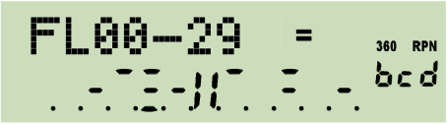

Within the numeric section, each row of horizontal bars in the mantissa shows the status of 10 flags. When a flag is set, the respective bar turns black. So here the top row of bars indicates flags 0 and 1 are clear, 2 and 3 set, and flag 4 clear. Then, the divider II separates the first group of five flags from the next. Top row bars on its right side indicate flags 5 and 7 are set. Next row of bars shows flags 11, 13, 14, 17, 19 are set, and in the lowest row only flag 23 is set. All other flags in the range from 10 to 29 are clear.

Scrolling down by  will display flags 10 - 39, then 20 - 49 etc. until 70 - 99, 80 - D, and 90 - D. Scrolling up by  reverts this. Alternatively, pressing a digit, e.g. 5, will show up to 30 flags starting with 10 times this digit, e.g. flags 50 - 79. The numeric exponent always indicates the status of the hotkeys top left on the keyboard – if all four labels are used in program memory then **ALL** will be displayed there.

The status will be displayed until any key is pressed but , , or a digit.

1. During **command input**, the dot matrix displays the command chosen until input is completed, i.e. until all required trailing parameters are entered. The prefixes , , and are shown until they are resolved. If you pressed any of , , or erroneously, recovery is as easy as follows:
   *   = NOP =   =   =   =  
   *   =   =   
       =   =   
       =   =

In addressing, progress is recorded as explained in the *tables above* in detail. You may cancel such pending operations by  as described *below*.

1. In **programming mode**, the numeric display indicates the program step (000 – 505) in the mantissa and the number of free steps in the exponent, while the dot matrix shows the command contained in the respective step, e.g.:

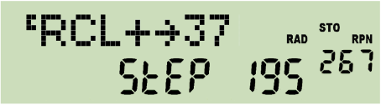

1. For **floating point decimal numbers**, the mantissa will be displayed adjusted to the right, the exponent to the left. Within the mantissa, either points or commas may be selected as radix marks[1], and additional marks may be chosen to separate thousands. Assume the display set to FIX 4, then 12.345678901 millions may look like:

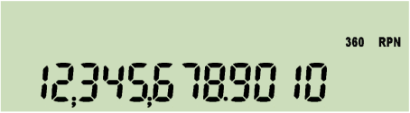 or 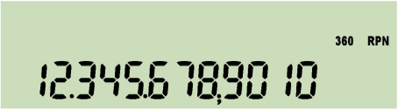

with thousands separators on, and without them like:

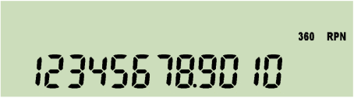 or 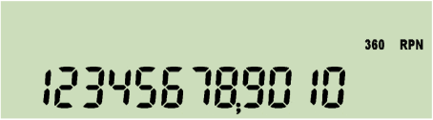

These separators may also be beneficial in integer or fraction modes described below. – With ENG 3 and after changing the sign, the same number will look like this:

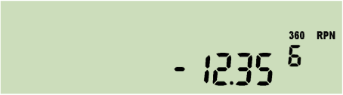 or 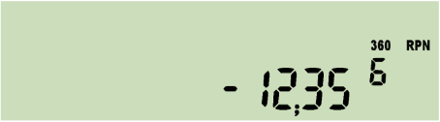

If the last operation executed was a complex one, a capital **C** is displayed top left in the dot matrix pointing to the fact that you find the result of this function in **X** and **Y**.

Floating point decimal numbers within ${10}^{-383}<x<{10}^{+385}$ may be entered easily. Using a decimal mantissa, even numbers down to 10–394 can be keyed in. The calculator works with numbers down to 10–398 correctly. Smaller values are set to zero. For results $x≥{10}^{+385}$, error 4 or 5 will appear (see *below*).

1. In **integer modes**, numbers are displayed adjusted to the right as well. Word size and complement setting are indicated in the dot matrix using a format ***xx.ww***, with ***xx*** being **1c** or **2c** for 1’s or 2’s complement, respectively, **un** for unsigned, or **sm** for sign-and-mantissa mode. Sign and first digit of the exponent show the base, a “c” in the second digit signals a carry bit set, an “o” in the third an overflow. Integer bases are indicated as follows:

|  |  |  |  |  |  |  |  |  |  |  |  |  |  |  |  |
| --- | --- | --- | --- | --- | --- | --- | --- | --- | --- | --- | --- | --- | --- | --- | --- |
| Base | 2 | 3 | 4 | 5 | 6 | 7 | 8 | 9 | 10 | 11 | 12 | 13 | 14 | 15 | 16 |
| Sign and 1st digit of  exponent displayed | **b** | **3** | **4** | **5** | **6** | **7** | **o** | **9** | **d** | **-1** | **-2** | **-3** | **-4** | **-5** | **h** |

The example shows the WP 34S an arbitrary number in unsigned hexadecimal mode with word size 64 and carry set:

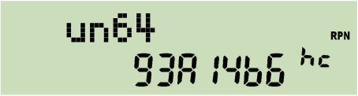

After changing to binary mode, this number will need 28 digits, being 1001001110100001010010110110. The 12 least significant digits will be displayed initially together with an indication that there are three display windows in total with the rightmost shown:

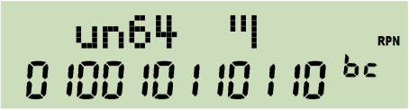

Now press  and you will get the next 12 digits in the middle window:

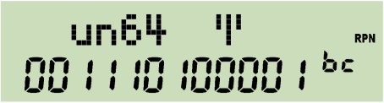

Press  again to show the most significant digits:

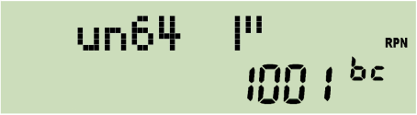

If leading zeros were turned on, there will be six display windows in this case, with the three “most significant” containing only zeros.

Please note numeric input is limited to 12 digits in any integer base.

1. **Fraction mode** works similar to HP-35S. In particular, DENMAX sets the maximum allowable denominator (see the *index of operations*). Display will look like in the examples below. If the fraction is exactly equal, slightly less, or greater than the floating point number converted, “=”, “Lt”, or “Gt” is indicated in the exponent, respectively. This mode can handle numbers with absolute values < 100,000 and > 0.0001. Maximum denominator is 9999. Underflows as well as overflows will be displayed in the format set before fraction mode was entered.

Now assume the WP 34S reset. Key in -47.40625  and you will see:

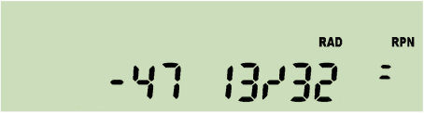 or after  : 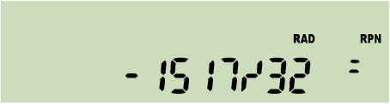 .

Please note integers like 123 will be displayed as “123 0/1” or “123/1” in fraction mode, respectively.

Squaring the improper fraction shown above results in

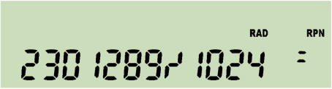

Now, enter  for converting this result into a proper fraction. You will get

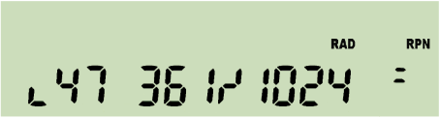

with a little hook left of the first digit shown. This indicates the leading number is displayed incompletely – there are at least two digits preceding 47 but no more display space. Press  to unveil the integer part of this proper fraction is 2247.

Input in fraction mode is straightforward and logically coherent.

|  |  |
| --- | --- |
| Key in: | and get in proper fraction mode: |
|  | 12 3/4 |
|  | 1 1/5 |
|  | 1/2 |
|  | 3/25 ( = 0.12 ) |
|  | 1 0/1 ( = 1 0/2 ! ) |

For comparison, please note the HP-32SII reads the last input here as ½ – which is, however, not consistent with its other input interpretations in fraction mode.

1. In **H.MS display mode**, format is hhhh°mm'ss.dd" with the number of hours or degrees limited to 9000. Output may look like this:

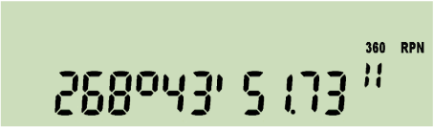 or 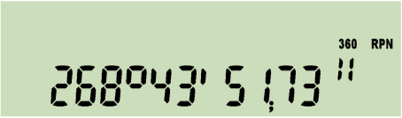

depending on the radix setting. For decimal times less than 5ms or 0.005 angular seconds but greater than zero, an “u” for underflow will be lit in the exponent section. For times or angles exceeding the upper limit, an “o” will be shown there signaling an overflow, and the value is displayed modulo 9000.

1. Output of the function **WDAY** will look as follows for an input of 1.13201 in M.DY mode (equivalent to inputs of 13.01201 in D.MY or 2010.0113 in Y.MD):

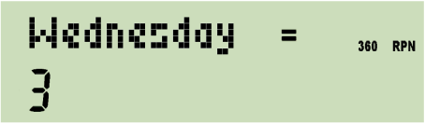

Expect similar displays after DAYS+. – Dates before the year 8 may be indicated differently to what they really were due to the inconsistent application of the leap year rule before this.

1. In **alpha mode**, the alpha register is displayed in the dot matrix, showing the last characters it is containing, while the numeric section keeps the result of the last numeric operation, e.g.:

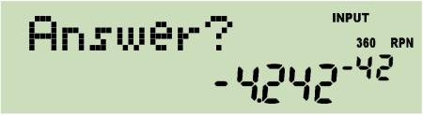

Different information may be appended to ***alpha***. See the commands starting with “α” in the index of operations below. E.g. αTIME allows creating texts like

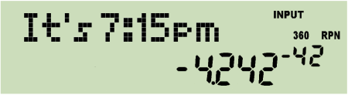 or 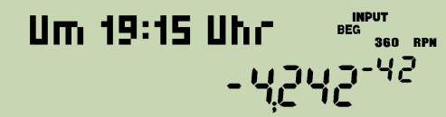

depending on time mode setting (12h / 24h). And αDATE will append – depending on date format setting – either 2011-04-16 or 16.04.2011 or 04/16/2011 to ***alpha***.

Please note ***alpha*** may contain up to 31 characters. And your WP 34S features a rich set of special letters. So you may easily store a message like

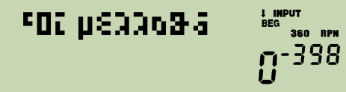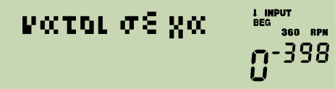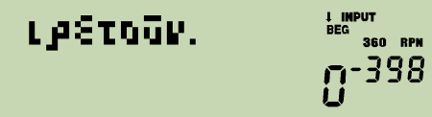

Use  and  for browsing it in steps of 6 characters. Browsing to the left will stop with the very first characters shown, browsing to the right stops showing the right end completely, i.e.

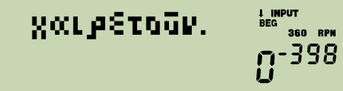

in this very special case.

**All keyboard input will be interpreted according to the mode set at input time.**

1. Starting here, decimal input is written using a point as radix mark throughout this manual, although significantly less visible, unless specified otherwise explicitly. By experience, the „comma people“ are more capable to read radix points and interpret them correctly than vice versa.